**6 Axis Articulated Bot**

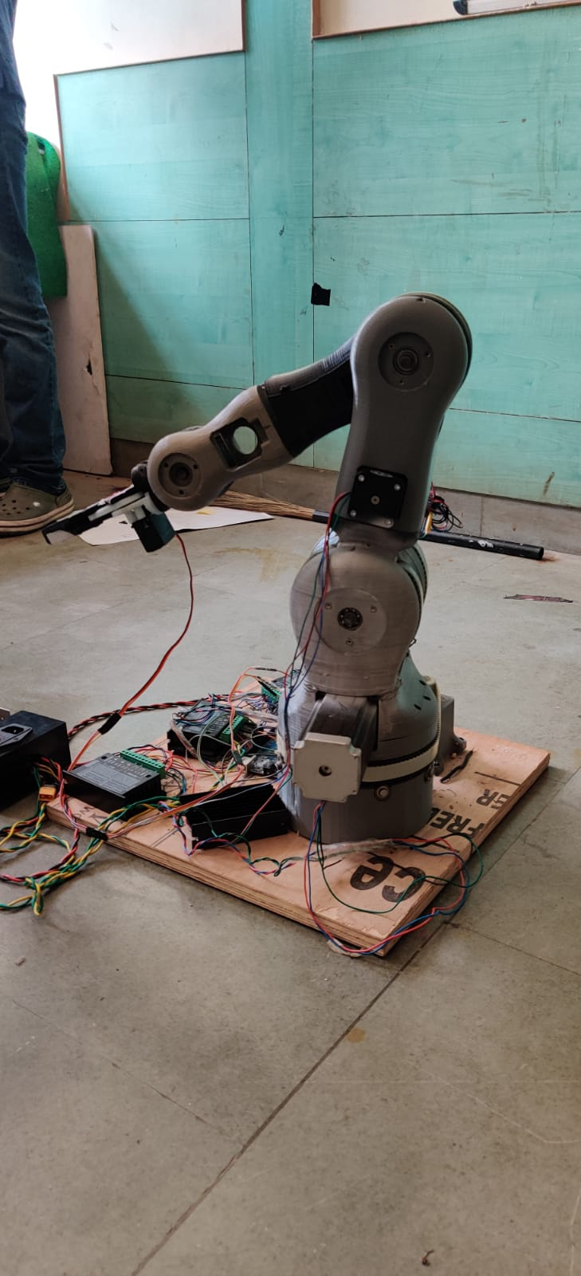

**Team Members:**

Kunal Awari (Coding)

Sarthak Gupta (Electronics)

**Components:**

Arduino Mega

Stepper Motors (4)

Servo Motors (1)

Micro Step Motor drivers (4)

**Libraries used:**

AccelStepper.h

Description:

It is an industrial robo arm which has 4 stepper motors to control 4 axis and a servo motor to control the gripper. For now it can grip small objects and drop them at desired locations. Using the AccelStepper.h driver we can control the speed , acceleration , angle and position of the stepper motors which then control the arm.